1. Create the DEPT2 table based on the following table instance chart. Place the
syntax in a script called lab_02_01.sql, and then execute the statement in the script to create the table. Confirm that the table is created.
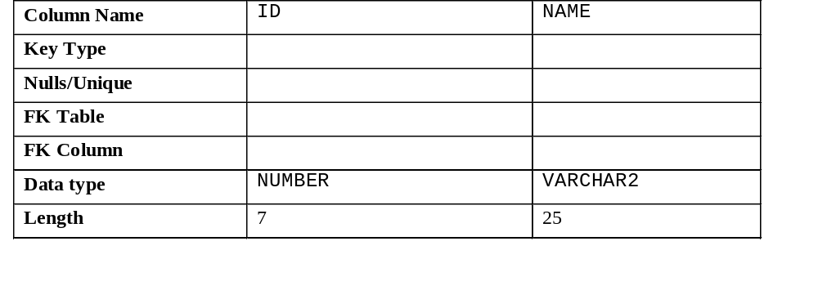

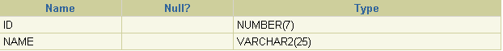
2. Populate the DEPT2 table with data from the DEPARTMENTS table. Include only the columns that you need.
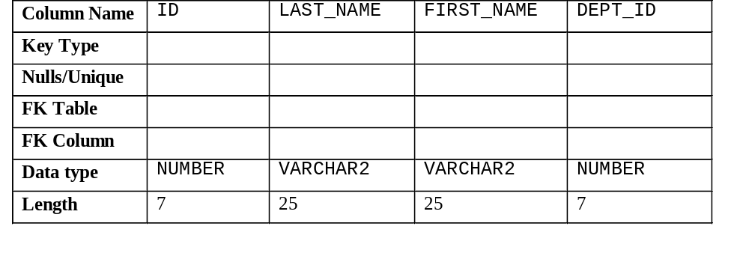3. Create the EMP2 table based on the following table instance chart. Place the syntax in a script called lab_02_03.sql, and then execute the statement in the script to create the table. Confirm that the table is created.

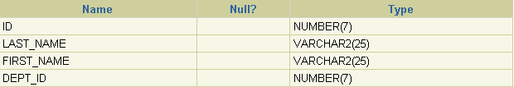
4. Modify the EMP2 table to allow for longer employee last names. Confirm your modification.
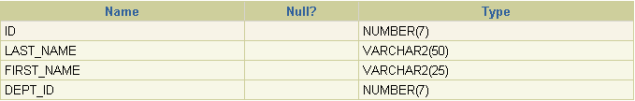
5. Confirm that both the DEPT2 and EMP2 tables are stored in the data dictionary.
(Hint: USER_TABLES)
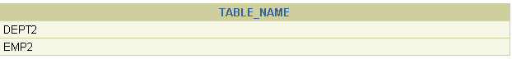
6. Create the EMPLOYEES2 table based on the structure of the EMPLOYEES table. Include only the EMPLOYEE_ID, FIRST_NAME, LAST_NAME, SALARY, and DEPARTMENT_ID columns. Name the columns in your new table ID, FIRST_NAME, LAST_NAME, SALARY, and DEPT_ID, respectively.
7. Drop the EMP2 table.
8. Query the recycle bin to see whether the table is present.
9. Undrop the EMP2 table.
10. Drop the FIRST_NAME column from the EMPLOYEES2 table. Confirm your modification by checking the description of the table.
11. In the EMPLOYEES2 table, mark the DEPT_ID column as UNUSED. Confirm your modification by checking the description of the table.
12. Drop all the UNUSED columns from the EMPLOYEES2 table. Confirm your modification by checking the description of the table.
13. Add a table-level PRIMARY KEY constraint to the EMP2 table on the ID column. The constraint should be named at creation. Name the constraint my_emp_id_pk.
14. Create a PRIMARY KEY constraint to the DEPT2 table using the ID column. The constraint should be named at creation. Name the constraint my_dept_id_pk.
15. Add a foreign key reference on the EMP2 table that ensures that the employee is not assigned to a nonexistent department. Name the constraint my_emp_dept_id_fk.
16. Confirm that the constraints were added by querying the USER_CONSTRAINTS view. Note the types and names of the constraints.
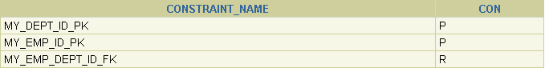

17. Display the object names and types from the USER_OBJECTS data dictionary view for the EMP2 and DEPT2 tables. Notice that the new tables and a new index were created.

